Dr. Ambedkar College, Deeksha Bhoomi
Department of Law
SMCA ACTIVITIES 2017-18
WORKSHOP ON MOOT COURT SKILLS : 6th Feb. 2018

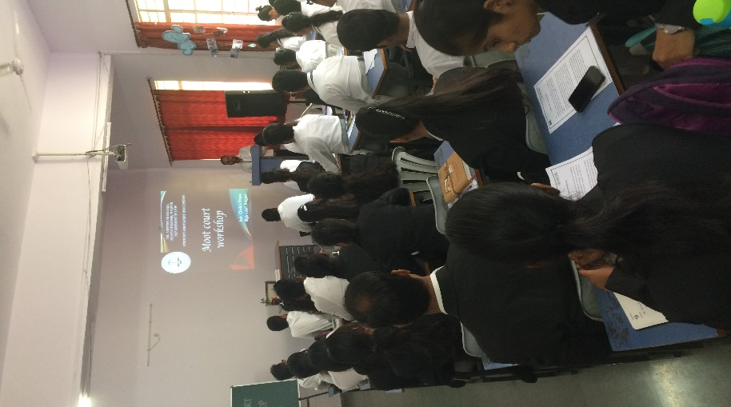
The workshop was held on 6th Feb, 2018 at 2pm for the students of law to introduce them with the mooting skills so that they can participate in different moot competition at across the nation. Adv. Chetan Dhore ably guided the students on Court ethics, how to conduct research, how to cite cases, ratio decedendi, case study etc. he also informed the students about prestigious moots conducted at various levels. Programme was conducted under the banner of SMCA and co-ordinated by Dr. Varsha Deshpande and Dr. Sandhya Kalamdhad.

Adv. Chetan Dhore addressing the students.

‘CONQUEST EXEMPLAR’ OF THE YEAR
This competition, based on Constitutional Law, is an idea conceived by the teachers of the Department of Law, with a view to instilling an enduring love for Constitutional Law amongst the students and for encouraging them to keep their quest for perpetual learning alive. It is for the very first time that an event like this has been organized in the Department.
This competition will include year long series of different events/ competitions based on Constitutional Law ranging from solving written objective question papers, to writing essays and research papers, making oral presentations, judgment analysis with critical appraisals, group discussions, quiz competitions etc. The evaluation of students will become more and more stringent with every successive round to make the event really competitive for the students. This competition will follow the system of eliminations after the third round and the best amongst them will be pushed to the next rounds. On the basis of their cumulative scores, the best student will be selected who will win the coveted title of "CON-QUEST EXEMPLAR OF THE YEAR 2017" along with a cash prize of ₹ 5001/-
Interested students were first asked to enroll for the competition and the entry was only through enrolment. A total of 44 students enrolled for it. So far two rounds of competition have been held. The first elimination will start after the first three rounds, on the basis of their cumulative score of all the three rounds taken together.
The first round was a written question paper with multiple choice questions. There were 50 questions with 50 minutes given to the students to solve it. This opening round was held on and had the enthusiastic participation of the contestants. The second round was also a written round but this time questions were without any choices, unlike the former multiple choice questions. This paper has 50 questions with 30 minutes allotted to the students for solving it. This was held on 11th August 2017. The third round which is scheduled on 6th Sept will have two parts- the first is a crossword puzzle and the other will have all case law based questions.
There are 3 pilot faculties of this ambitious project: Dr Mrs Varsha Deshpande, Ms. Saylee Surjuse & Mrs. Vaishali Sukhdeve.
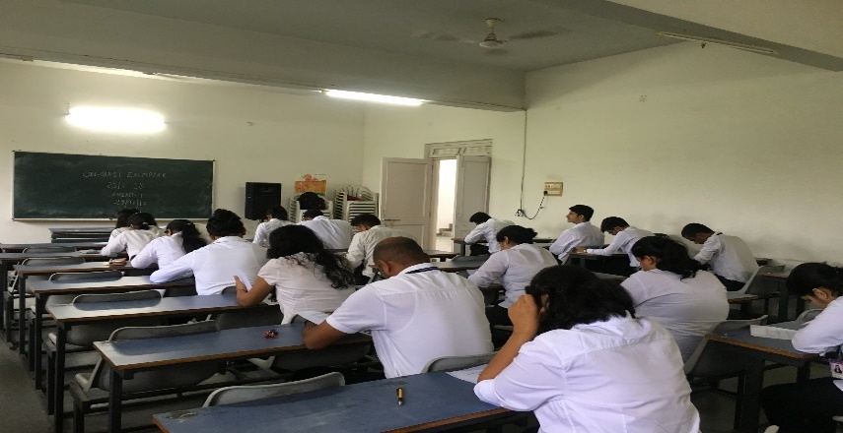
First round of the Conquest Exemplar
CONQUEST EXEMPLAR 2017-2018
- The Event I was held on 29th July 2017 which was a Multi choice Question paper of 100 marks without negative marking. Total 44 participants participated from different classes.
- The Event II was held on 11th August 2017 which was a Multi choice Question paper of 100 marks with negative marking. Total 44 participants participated from different classes.
- The Event III was held on 7th September 2017 which was a Crossword round of 100 marks with negative marking. Total 44 participants participated from different classes.
After three events elimination started. On the basis of cumulative scores of three events Top 20 participants were pushed ahead in next round.
- The Event IV was submission of research paper on the topic of Right to Privacy and its various sub themes. The last date for paper submission was 11th December.
- The Event V was held on 13th January 2018 which was a Research paper presentation round, in which total 13 students presented their paper. The topic was Right to Privacy and its various sub themes The examiners to judge this event were Adv. Renuka Sirpurkar and Adv. Shradhanand Bhutada.
- The Event VI was held on 10th February 2018 which was a Judgement analysis round, in which total 09 students participated which were shortlisted on the basis of their previous rounds cumulative scores. The examiners to judge this event were Adv. Priti Rane and Adv. Ritesh Tahaliyani. The case given for analysis was ABC vs. State 2015 SCC 609.
- The Final round of the event was a Constitutional quiz which was held on 20th February 2018 in the College auditorium. The top 4 finalist were selected on the basis of cumulative scores of all events. The quiz was conducted by Dr. Varsha Deshpande. The Conquest Exemplar 2017-2018 was won by Ms. Priyanka Bodhankar, a cash prize of Rs. 5000/- which was sponsored by Dr. Varsha Deshpande. The prize were given at the valedictory function of law-Vision 2018 at the hands of J. Mrs. Naik, High Court, Nagpur.
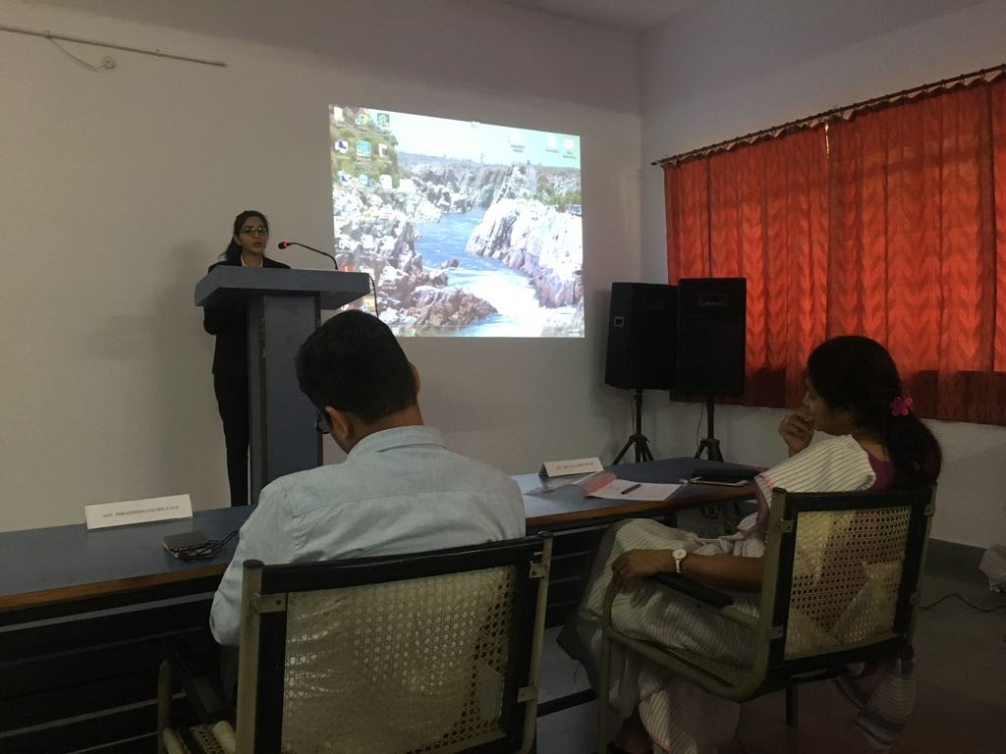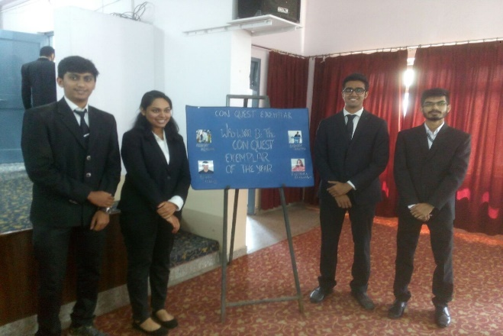
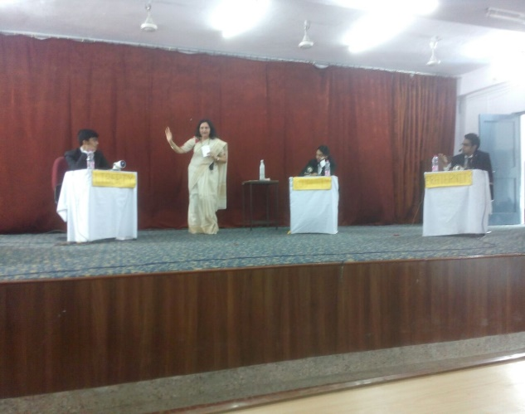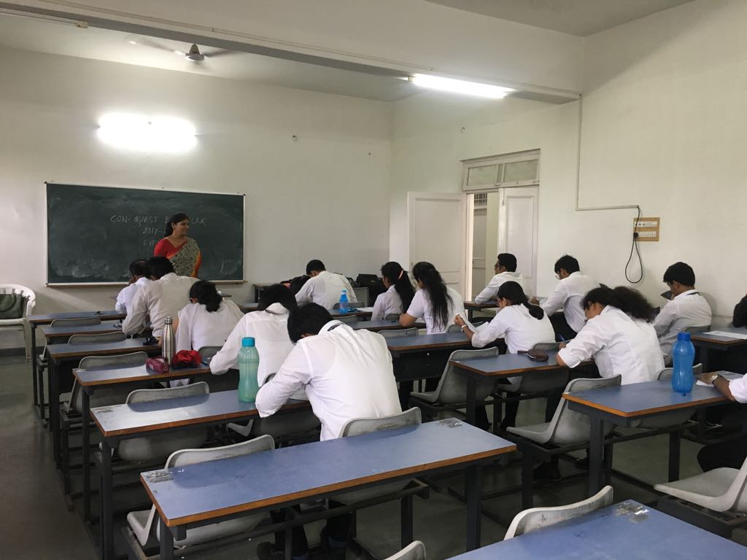
Students participation in different competitions during conquest Exemplar

Law Vision - 2018
Law Vision is a highly sought after premiere law festival that is organized by the Department of Law every year. The Department has been hosting this event for the last 11 years and this was the twelfth consecutive year of this mega law festival. Law Vision 2018 was hosted by the Department from 22nd Feb to 25th February this year and it received an overwhelming response. In all 14 teams from all across the country, including from far-flung places like Andaman participated in this academic extravaganza and all the teams gave a tough fight at various challenging competitions at Law Vision. This year events like Moot Court competition, Client Counselling competition, Case-Study, Legal Drafting, Essay Competition and Personality Contest were a part of Law Vision – each one testing the requisite skills necessary for emerging as successful professionals. The corridors of the Law Department were all set to host this grand event, decorated as they were with beautiful rangolis and several charts and other displays made by our own talented students.
This year, Law Vision was inaugurated in a glittering Inaugural ceremony on Thursday, the 22nd of February at 6 pm in the College Hall. The Inauguration ceremony got under-way in the presence of towering legal personalities. Justice B P Dharmadhikari, the Senior Administrative Judge of the Nagpur Bench of the Bombay High Court was the Chief Guest of the Ceremony and the Hon’ble Vice Chancellor of the Maharashtra National Law University was the Guest of Honour. Also Hon’ble Mr Mohan Pieres, the Former Chief Justice of Srilanka graced the occasion as a Special Guest. The motivational speeches of all these legal luminaries set the tone and marked a wonderful beginning of this Law festival!
The second day of the event i.e. 23rd of February began with the Client Counselling competition for all the participating teams. This Competition is organized with a view to train the future lawyers in the art of receiving instructions from the client and the kind of interaction that a lawyer must have with the client in order to muster his confidence. It also seeks to test the professional ethics of these would-be lawyers and their understanding about the duty that lawyers owe to their clients and to the court. This competition was ably judged by Adv Suyog Deshpande and Adv Ashwini Shukul. The event was co-ordinated by Ms Sayalee Surjuse, Ms Aditee Godbole and Ms Shazia Bari.
Soon after this, a Legal Drafting competition was also organized for the teams, wherein, the teams were asked to draft some important legal documents like Notice, Plaint, Affidavit, Sale-Deed etc. The teams were adjudged on the basis of their compliance to formal rules of drafting as well as the content and comprehensiveness of the draft. Drafting skills are at the very heart of the lawyers profession and hence this competition was organized with a view to hone their drafting skills. The event was co-ordinated by Dr Pratima Lokhande and Ms. Shilpa Rathod and judged by Adv Chetan Dhore from the High Court.
After this, the second half of the day was marked by the conduct of the Preliminary Rounds of the Moot Court competition. The students were required to prepare the given case, draft memorials and argue the matter like it is done in the Court of Law. The Moot Court event requires a student to master all skills of a lawyer like studying and appreciating the case, framing of issues, researching the case law, drafting the memorials and actually arguing the matter. This was a tough competition indeed and in the Preliminary round, the teams were required to argue from both sides. There were 7 court rooms created for this event and the following lawyers from the Nagpur High Court did a fine job of grilling the teams on different issues relating to the case. The able judges were: Adv Akshay Naik, Adv Saurabh Chaudhary, Adv Tajwar Khan, Adv Deoul Pathak, Adv Trupti Udeshi, Adv Akshay Sudame, Adv Richa Tiwari, Adv Prasad Abhyankar, Adv Ritesh Tahaliyani, Adv Rohan Joshi, Adv Preeti Rane, Adv Ritesh Badhe, Adv Rahul Dhande and Adv Ranjit Bhuibhar. The second day of Law Vision ended with testing and grilling rounds of the Preliminary rounds of the Moot Court competition. All rounds of the Moot Court Competition were co-ordinated by Dr Varsha Deshpande, Ms Aditee Godbole and Mr Sachin Tripathi.
The third day of Law Vision i.e. 24th February, Saturday, began with an eloquent lecture by one of the finest legal brains in the country, Adv Prashant Bhushan , who was invited from the Supreme Court of India. This Guest Lecture became the headline of this Law festival and drew a huge crowd of listeners from the entire legal fraternity in Nagpur and also others unconnected with the profession. He delivered an erudite address on a topic of contemporary significance, namely, “Judicial Accountability and Judicial Reforms”. In a jam-packed auditorium, this guest lecture sought to bring some fresh thinking on the young minds about the urgent need for making the judiciary accountable. The lecture was followed by an open – house session in which the students and participants got an opportunity to interact with the guest speaker and ask him certain questions. The Guest lecture was given a wide and extensive coverage by the media.
This day, that began on such a wonderful note, kept that spirit going through the Case-Study competition in which the teams were given one case, namely Shreya Singal vs Union of India and the students were expected to critically appraise the judgment. This competition enhances their insight and ability to appreciate the law. This competition was ably judged by Adv Nahush Khubalkar, Adv Vivek Awachat and Adv Mahendra Limaye. The Case- Study competition was co-ordinated by Dr Sandhya Kalamdhad, Ms Vaishali Sukhdeve and Ms Shilpa Rathod. This was followed by a Semi-final round of the Moot Court competition. 4 teams from the Preliminary Rounds, on a two-win basis were pushed into the Semi-final round. The level of this evaluation at this round was tougher still and the teams were judged by Adv Uday Dastane and Adv Shreerang Bhandarkar – both very senior Lawyers practicing in the Nagpur High Court. With such tough and testing competitions, ended the third day of Law Vision.
The final day of this law fest began in the morning with the Final round of the Moot court competition. 2 teams from the Semi-final round were pushed into the final round. This final round of the Moot Court competition was indeed a very prestigious one. It was judged by two esteemed judges of the Nagpur Bench of the Bombay High Court Hon’ble Mr Justice V M Deshpande and Hon’ble Mr Justice Rohit B Deo. The auditorium was jam packed with students who had keenly come to see this final round. The end of this Final round of the Moot Court event navigated us to the Personality Contest which was yet another much enjoyed event at Law Vision. The students were subjected to different rounds and eliminations were done in each round. But all the rounds were carefully crafted so as not to lose our essential legal touch. Out of a total of 15 students, Mr Personality and Ms Personality were declared. This competition was also enjoyed by the audience present in large numbers and was judged by Adv Wilson Mathew and Ms Ketki Kane Salankar, who also happens to be the alumnus of our Department. The Personality Contest was co-ordinated by Dr Mrs Hema Menon and Ms Saylee Surjuse.
The essay competition at Law Vision 2018 required an online submission of the essays on the topic “New Horizons of the Concept of Human Dignity”. All Essays were subjected to an anti-plagiarism check. They were evaluated by Prof Dr Shirish Deshpande, Former Head of PGTD Law, RTM Nagpur University. This competition was co-ordinated by Ms Shazia Bari, Mr Rahul Dhoble and Mr Sachin Tripathi
After the Personality Contest, it was time to conclude this fun-and-learning packed Law festival. Hon’ble Smt Justice Vasanti Naik from the Nagpur Bench of the Bombay High Court was the Chief Guest at the Valedictory Session of Law Vision 2018. Her motivational speech to the students was widely appreciated. The prizes of all the events were distributed in the Awards ceremony at the Valedictory session. Attractive cash prizes were given away for all the winners and runner-up at all events.
With this wonderful valedictory session, were drawn the curtains on this academic extravaganza of the Department of Law - “Law Vision 2018”!
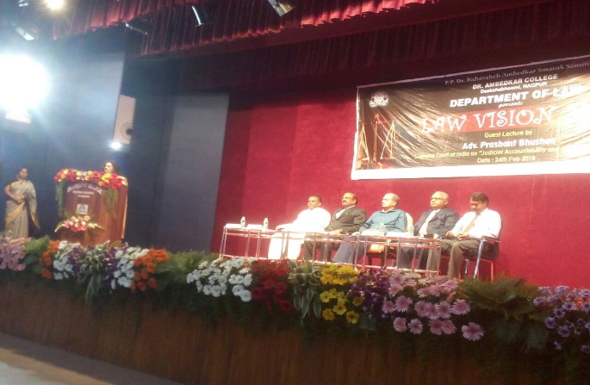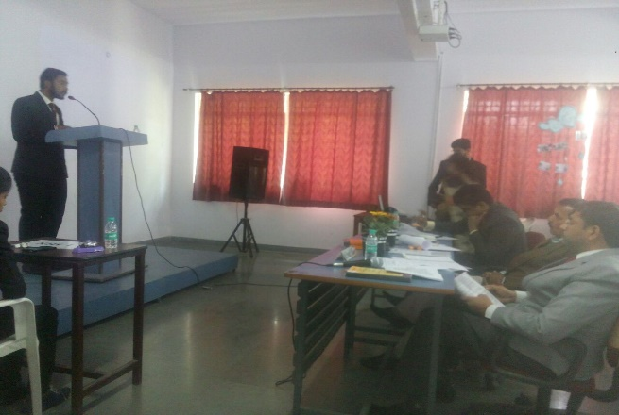
Adv. Prashant Bhushan alongwith other dignitaries & three judges judging case study competition

